**MODULE: 2 (CSS and CSS 3)**

**• What are the benefits of using CSS?**

1. Useful for separation of content & design.
2. Keeps code neat and easier to understand.
3. Increases performance.
4. Reduces HTML file size.
5. Easy to apply global styles.

**• What are the disadvantages of CSS?**

1. Large projects can make CSS hard to understand.
2. Styles can override each other.
3. Managing specifying rules can be confusing.
4. Hard to debug.
5. If we apply change in HTML structure, CSS needs to be changed.

**• What is the difference between CSS2 and CSS3?**

|  |  |
| --- | --- |
| **CSS2** | **CSS3** |
| Uses basic selectors. | Uses advanced selectors. |
| Limited support for media queries. | Uses media queries to make website or webpage responsive. |
| Uses basic box model with height, width, margin and padding. | Added box-sizing property to control the box model. |
| Basic styling and visual effects. | Uses new visual effects. |
| Does not support transitions and animations. | Uses 2D & 3D Animations and transitions. |

**• Name a few CSS style components**.

Few CSS Style Components are :-

1. Selectors:- “.class”, “#id”, “element”, etc.
2. Properties:- “color”, “background-color”, “text-decoration”, etc.
3. Value:- “red”, “2px”, “30%”, etc.

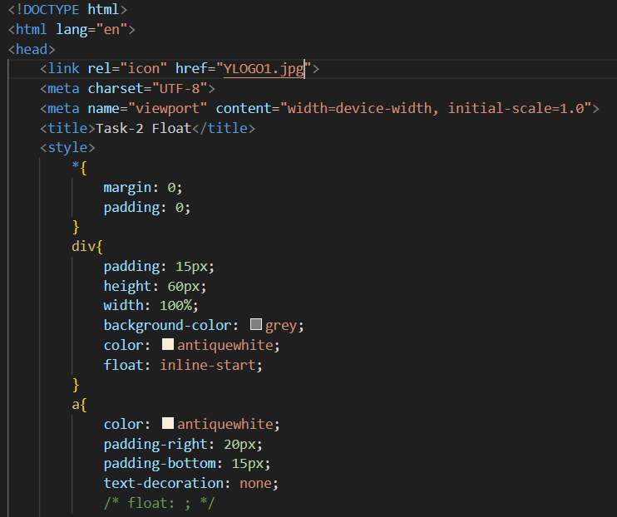

**• What do you understand by CSS opacity?**

CSS opacity is a property that allows user to control the transparency level of an element.

Its value ranges from ‘0’ to ‘1’.

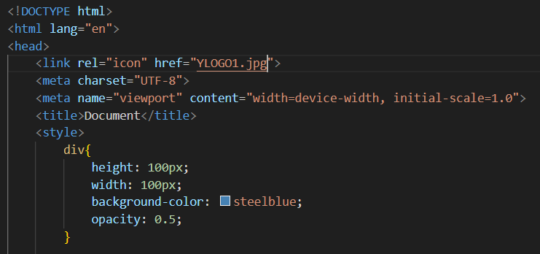

**• How can the background color of an element be changed?**

Background-color of an element can be changed by using **“background-color: ;”** property of CSS.

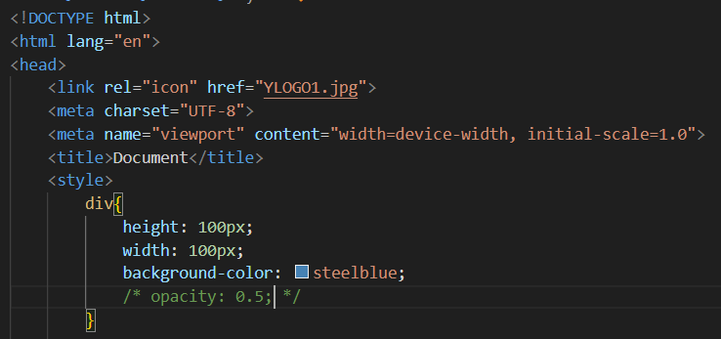

**• How can image repetition of the backup be controlled?**

Image repetition of the background-image can be controlled by using **“background-repeat: ;”** property.

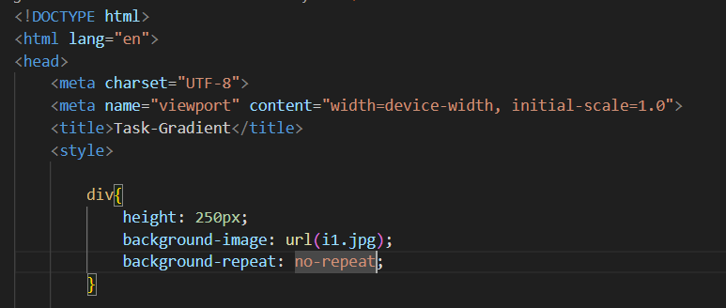

**• What is the use of the background-position property?**

It sets the starting position of a background image.

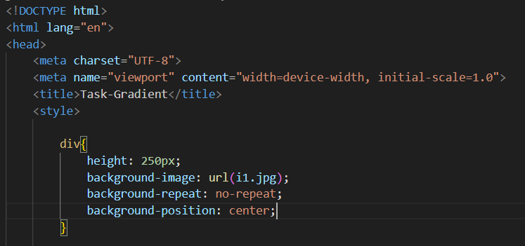

**• Which property controls the image scroll in the background?**

The property that controls the image scroll in background is **“background-attachment: ;”.** It has three values scroll(default), fixed & local.

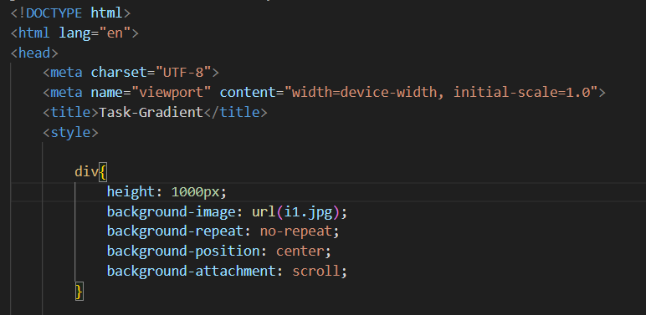

**• Why should background and color be used as separate properties?**

Background and color are used as separate properties because **“background”** is used to change any CSS properties regarding the background of any web page, while, **“color”** changes the text-color of content written in any element.

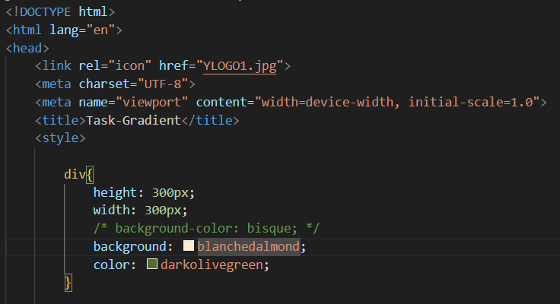

**• How to center block elements using CSS1?**

To center block elements using CSS1, set the element’s display property to block. Then adjust width if needed. At last use “margin: auto;”, to center the element horizontally

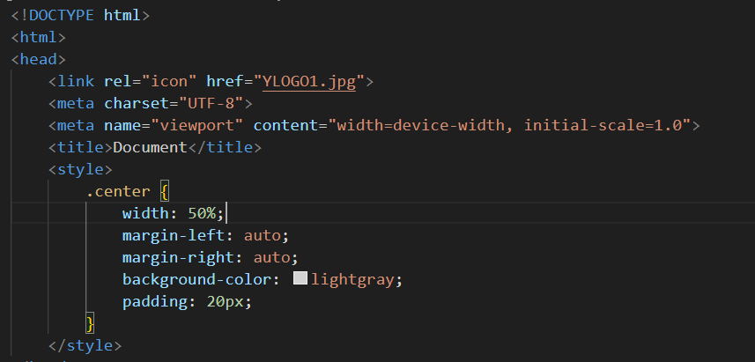

**• How to maintain the CSS specifications?**

1. Use valid CSS syntax.
2. Organize code which is easy to read and understand.
3. Use proper id and/or class whenever required.

**• What are the ways to integrate CSS as a web page?**

There are mainly three ways to integrate CSS as a web page:-

1. Inline CSS.
2. Internal CSS.
3. External CSS.

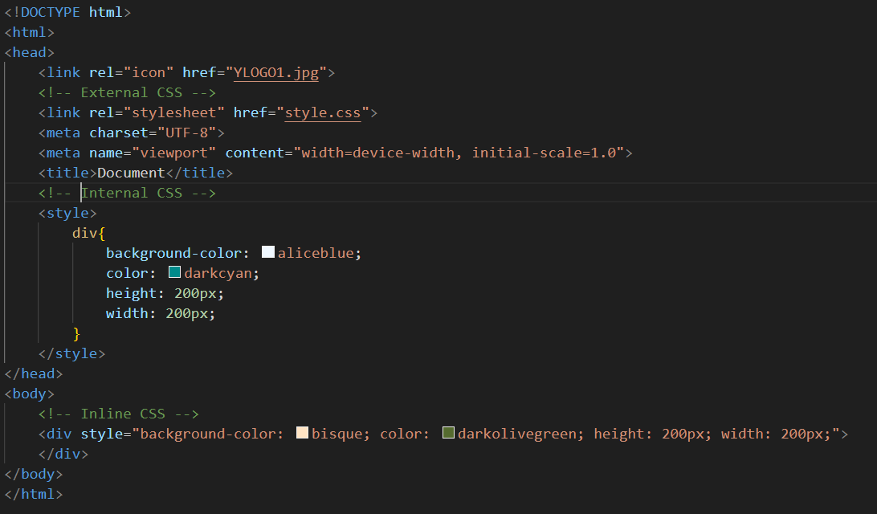

**• What is embedded style sheets?**

**Embedded style sheets** are CSS rules defined within an HTML document. They are placed inside the **“<style>”** tag within the **“<head>”** section of the document. This method allows user to apply styles to the document without using external CSS.

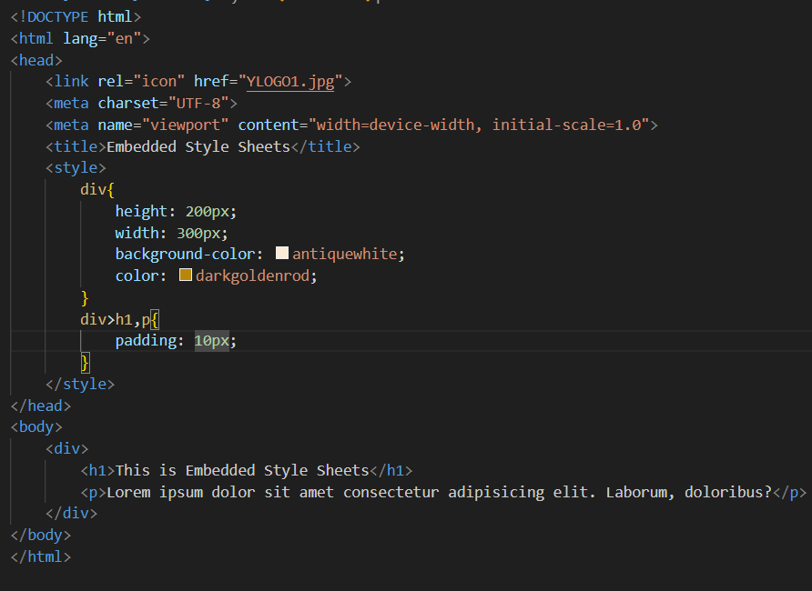

**• What are the external style sheets?**

External style sheets are CSS files that are stored separately from the HTML document. They contain CSS rules that can be linked to multiple HTML documents. External file must be saved with the extension **“.css”.**

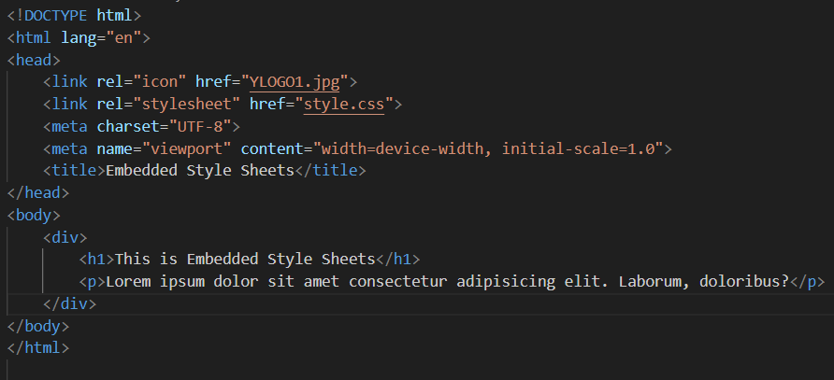

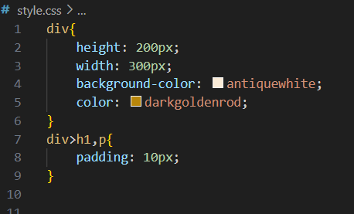

**• What are the advantages and disadvantages of using external style sheets?**

***Advantages:-***

1. Ensures a uniform look and easy to understand.
2. Updating a single CSS file updates, all the documents in which that CSS file is linked.
3. We can separate the HTML & CSS content improving code organization.
4. HTML codes becomes shorter.

***Disadvantages:-***

1. If the CSS file fails to load, the webpages may appear un-styled.
2. Fow very small webpage or website, maintaining the separate CSS file can be unnecessary overhead.
3. The initial load time may be longer.

**• What is the meaning of the CSS selector?**

CSS selectors are used to find or select the HTML elements that the user wants to style. It specifies which element in an HTML document should be targeted by CSS rules, allowing user to apply styles to specific elements.

Few examples of CSS selectors are:-

1. Universal Selector(*)- Selects all the HTML elements on the page.
2. Element Selector- Selects the specific element in the page.
3. Group Selector- Selects more than one elements in the page.
4. Class Selector(.)- Selects specific element with the specific class name.
5. Id Selector(#)- Selects specific id element which is unique on the webpage.

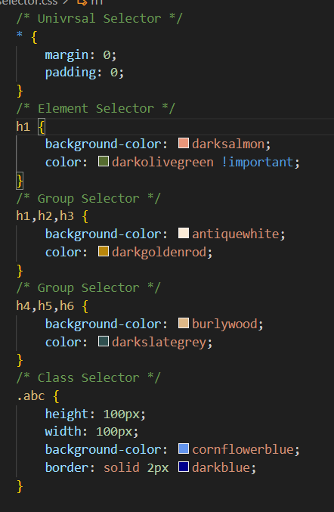

**• What are the media types allowed by CSS?**

CSS allows several types of media that allows user to apple styles based on the type of device or media displaying the content.

1. all: Suitable for all devices.
2. print- Intended for the specific paged documents or materials.
3. screen- Designed primarily for computer screens, tablets, smartphones, etc.
4. speech- Intended for speech synthesizers.

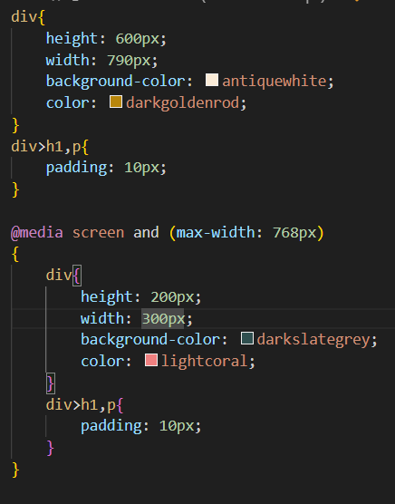

**• What is the rule set?**

A CSS rule set consists of a selector and a declaration block.

The declaration block contains the property and value of the selector.

**Selector{Declaration}**

**Or Selector{Property:Value;}**

